HW9 deadline: 2020/05/12

Please find the attached for the Simulink model for the UAV.

The homework is to **design a geometric controller** to track a desired attitude.

e.g., $R_{d}=\left[\begin{matrix}1 & 0 & 0 \\ 0 & \frac{1}{2}cos⁡(t) & \frac{\sqrt{3}}{2}sin⁡(t) \\ 0 & -\frac{\sqrt{3}}{2}sin⁡(t) & \frac{1}{2}cos⁡(t)\end{matrix}\right],x_{d}=[0 0 2]$

1. You need to modify “**controller.m**”
2. There is explanation for every function in “**readme.txt**”
3. 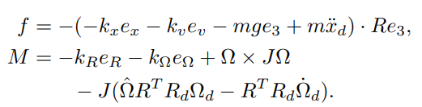Don’t implement this term.